
Flying IS for Girls!
A STEM program for Junior & Cadette Girl Scouts

Offered by the Dallas Chapter of the Ninety-Nines,
an International Organization for Women Pilots
This seminar is led by women pilots.

Date: February 4, 2017
Duration: 3 hours, 9am – 12pm
Location: Frontiers of Flight Museum at Dallas Love Field
Attendance Fee: $15/girl covers Admission, Materials, Snack, and STEM patch; $5/adult

Join us to:

 | Discover how airplanes fly. Assemble a model plane. |  | Share historical perspectives with a former air racer.
 | Learn about important aviation websites and careers. | 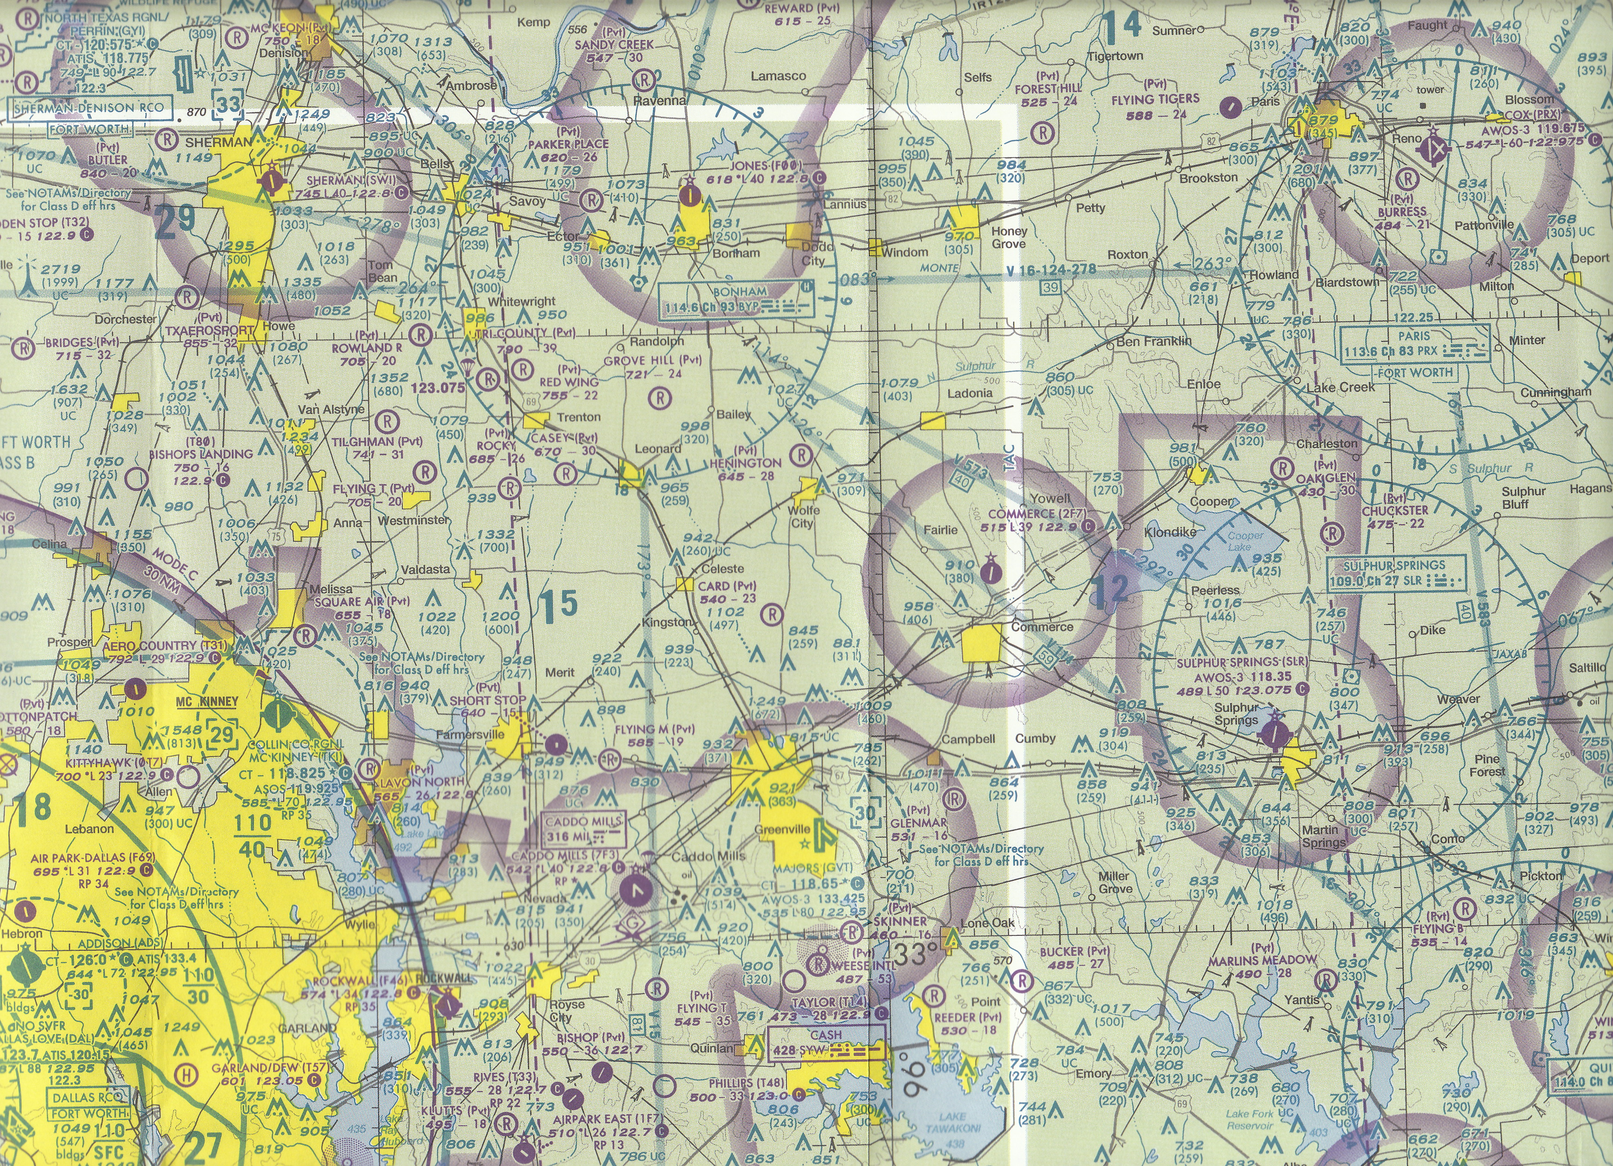 | Map out a route of flight and identify key features to look for and look out for.
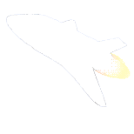 | Sample space food and identify space exploration spin-offs. | 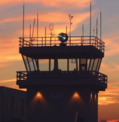 | Visit the Frontiers of Flight Museum. Practice your Aviation ABCs.

www.dallas99s.org
For more information or to request space at the seminar,
contact Janny Strickland at travelerjs@gmail.com.

 The Ninety-Nines is an International Organization of Women Pilots, founded in 1929

